



Functions Factory
LAB MANUAL

Disclaimer: The content is curated from online/offline resources and used for educational purpose only
Functions Factory – Reusable Helpers

Objective
By the end of this lab, you will be able to:
- Use GitHub Copilot to define and create functions in Python with parameters and return values.
- Understand why functions make code reusable, organized, and easier to maintain (DRY principle: Don't Repeat Yourself).
- Prompt Copilot effectively with clear, descriptive comments to generate complete function definitions.
- Call functions multiple times in a program with different inputs.
- Build small helper functions for common tasks (e.g., math calculations, checks, greetings).
- Compare writing functions manually vs. using Copilot suggestions to appreciate the time saved.
- Test functions independently and fix minor issues with Copilot assistance.
Equipment Required
- Computer/Laptop with Windows, macOS, or Linux.
- Visual Studio Code (VS Code) installed and configured.
- Python 3.10 or higher installed and added to PATH.
- GitHub Copilot extension installed and activated in VS Code (signed in with GitHub account).
- Internet connection (required for real-time Copilot suggestions).
- Optional: Notepad or worksheet for noting prompts and observations.

Prerequisites
- Completed Module 3 and Lab 1 of Module 4 (comfort with loops, input/output, if-else, and basic Copilot usage).
- Able to create/run .py files in VS Code terminal (using green play button or right-click → Run Python File).
- Familiar with accepting Copilot suggestions (Tab), choosing alternatives (arrows), and rejecting (Esc).
- Basic variables, print(), input(), and simple math operations.

Procedure
Follow these steps sequentially.
- Preparation
  - Open VS Code.
  - Navigate to your Module 4 labs folder (e.g., "Module4_Labs").
  - Create a new file: lab2_functions_helpers.py.
  - Save it (Ctrl+S) and ensure Python interpreter is selected (bottom status bar).
  - Add header comments:
# Lab 2: Functions Factory – Reusable Helpers
# Objective: Use Copilot to create and call functions
# Date: [Your Date]
- Part A: Simple Greeting Function
  - Type this comment and press Enter twice:
# Function to greet a user by name
# Takes name as parameter, prints "Hello, [name]! Welcome to Python."
  - Copilot should suggest something like:
def greet(name):
print(f"Hello, {name}! Welcome to Python.")
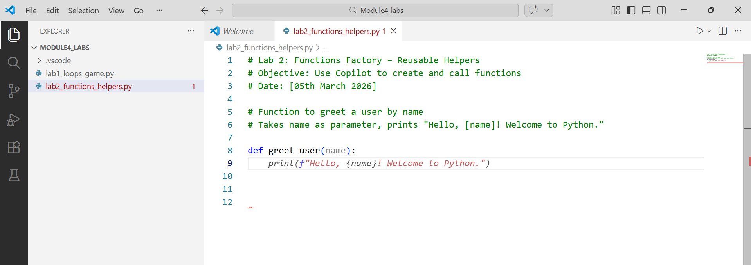
    - Accept (Tab) if it matches. If not ideal, refine prompt: # Function greet_user(name): print personalized welcome message
  - Below it, call the function:
greet("Rahul")
greet("Priya")
  - Run the file. See two greetings printed.
  - Experiment: Change the message inside the function → rerun. Note how one change affects all calls (reuse benefit).
- Part B: Math Helper – Square and Cube Functions
  - New section comment:
# Function to calculate and return the square of a number
  - Copilot likely suggests:
def square(num):
return num * num
    - Accept and add:
# Function to calculate and return the cube of a number
    - Let Copilot generate def cube(num): return num ** 3 or similar.
  - Test calls:
print("Square of 5:", square(5))
print("Cube of 3:", cube(3))
user_num = int(input("Enter a number: "))
print("Its square:", square(user_num))
  - Run and test with inputs. Observe: Functions return values you can print or use later.
- Part C: Even/Odd Checker Function
  - Add comment:
# Function is_even(number): returns True if even, False if odd
# Use % operator
  - Copilot should generate:
def is_even(number):
return number % 2 == 0
  - Use it in a loop (combine with Lab 1 knowledge):
# Test with numbers 1 to 10
for i in range(1, 11):
if is_even(i):
print(f"{i} is even")
else:
print(f"{i} is odd")
  - Prompt improvement if needed: # Function check_even_odd(num) that prints whether number is even or odd
- Part D: Mini Calculator Helpers – Add and Multiply
  - Final set of functions:
# Function to add two numbers and return the sum
# Function to multiply two numbers and return the product
  - Let Copilot create:
def add(a, b):
return a + b

def multiply(a, b):
return a * b
  - Build a small program:
num1 = float(input("Enter first number: "))
num2 = float(input("Enter second number: "))
print("Sum:", add(num1, num2))
print("Product:", multiply(num1, num2))
  - Run multiple times with different numbers.
- Reflection & Quick Testing
  - Run the entire file. Fix any small errors (e.g., TypeError) by highlighting line → type # fix this or use Copilot Chat (if available: Ctrl+Shift+I → ask "why error here?").
  - Worksheet notes:
    - Best prompt you used today?
    - How many lines did Copilot write vs. you?
    - One advantage of functions you noticed.
    - One challenge (e.g., wrong parameter name) and how you fixed it.

Conclusion
In this lab, you used GitHub Copilot to quickly build reusable functions - small, named blocks of code that perform specific tasks. Functions help avoid repetition, make programs cleaner, and easier to debug or expand later (e.g., change logic in one place only). Copilot excelled at turning natural-language comments into correct function syntax, parameters, and return statements when prompts were clear and specific.

